**Use a theme to change the colors of your SharePoint site**

You can choose one of the default SharePoint themes and customize it as needed, choose a company theme with approved branding for your company, or use one of the classic experience designs. To create and upload a company theme, see [SharePoint site theming](https://docs.microsoft.com/en-us/sharepoint/dev/declarative-customization/site-theming/sharepoint-site-theming-overview).

1. On your site, click **Settings** Settings for SPO Migration tool and then click **Change the look** > **Theme**.
2. Select the look you want. You'll see a preview of what your site looks like with the selected theme applied. Click **Save** to apply it to your site or, if you don't like what you see and want to revert back to what you had in the beginning, click **Cancel** instead.

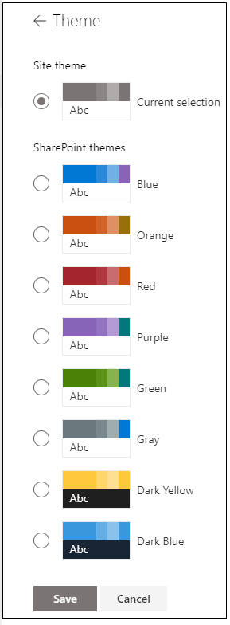

1. To customize the colors of one of the default SharePoint themes, select the theme and then click **Customize**.

Choose the main color and accent color you want, and then click **Save** to apply it to your site. You can also select whether or not a grey (**Neutral**), light (**Soft**) or dark (**Strong**) version of the main color is applied to the header of your site or you can keep the default white header background. The list of main colors and accent colors varies depending on the default SharePoint theme you choose to customize.

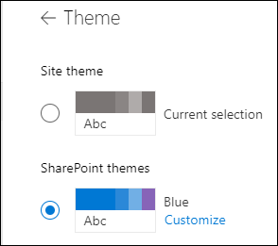

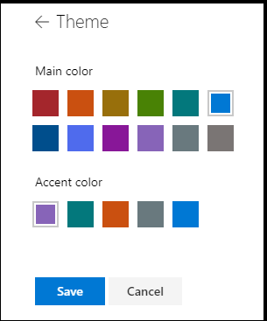

Change the color, background, or font with classic experience themes

If your administrator has sites set to the classic experience, or you're changing the theme of a subsite, follow these steps to change the color, background, and font of your SharePoint site:

1. On your site, click **Settings** Office 365 Settings button and then click **Change the look**.
2. Click **View classic settings** or **Classic change the look options**. If you're already in the classic experience, skip this step.

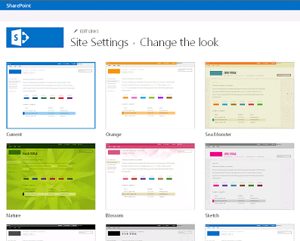

1. Choose a look from among the choices. Don’t worry if you don’t like the color or the image exactly, you can change that in the next step.
2. To add or change the background image, click **Change** to upload an image of your own, or drag an image from your computer onto the thumbnail image above the **Change** command.

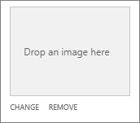

1. To change the color scheme, click the arrow next to **Colors** and select another color scheme.

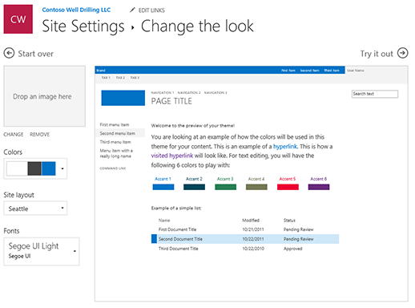

1. To change the layout, click the arrow next to **Site layout** and select another layout, which controls the position of the navigation links, search box, and so on.
2. To change the fonts, click the arrow next to **Fonts** and select another font.

**Note:**You can change the font type style, but you can't change the size.

1. When you’re ready to see a full-sized preview of how your changes look when applied to your site content, click **Try it out**. The changes are not yet visible to other site users.

**Note:**If you don't like what you see and want to revert back to what you had in the beginning, click **Start over** or you can click your site logo to exit **Change the look** and go back to the home page of your site.

1. If you like what you see in the preview, click **Yes, keep it**. If not, click **No, not quite there** and try something else.

